Louis Alvin Daugherity

April 25, 1932 – January 19, 1939

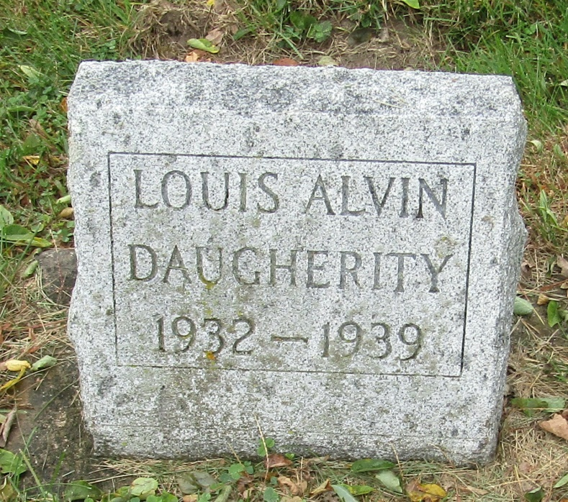

Louis Alvin Daugherity from tree Caven Family Tree  
Record information.  
Birth 25 Apr 1932  
Death 19 Jan 1939 Indiana, USA  
Record information.  
Father Arther E Daugherity (1897-1966)  
Record information.  
Mother Hazel E Earp (1912-1972)