Paul Richard Cotton
January 6, 1926 – May 1, 1938

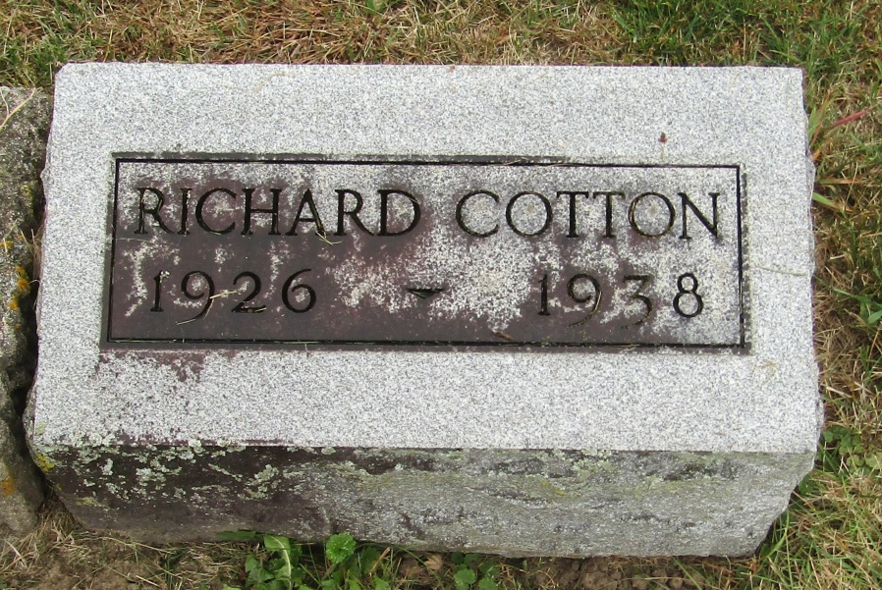

Name: Paul Richard Cotton
Event Type: Death
Event Date: 01 May 1938
Event Place: Columbus, Franklin, Ohio
Residence Place: Mifflin, Franklin, Ohio
Address: 3243 Agler Road
Gender: Male
Age: 12
Marital Status: Single
Race: White
Occupation: Student
Birth Date: 06 Jan 1926
Birthplace: Columbus, Ohio
Birth Year (Estimated): 1926
Burial Date: 03 May 1938
Burial Place: Blufton, Ind.
Father's Name: Paul Cole Cotton
Father's Birthplace: Wells, Ind.
Mother's Name: Leota Irene Buel
Mother's Birthplace: Wells, Ind.

