George S. W. Boyer
March 1, 1857 – March 7, 1944

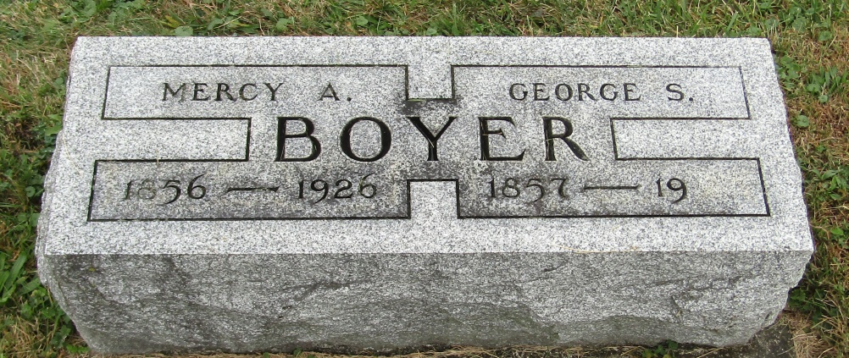

George S Boyer
in the Indiana, Death Certificates, 1899-2011
Name: George S Boyer
Gender: Male
Race: White
Age: 87
Marital status: Married
Birth Date: 1 Mar 1857
Birth Place: Penn
Death Date: 7 Mar 1944
Death Place: Bluffton, Wells, Indiana , USA
Father: Elias Boyer
Mother: Sophia Smuth
Spouse: Mary Bennet
Informant: Mrs. George Boyer; city
Burial: March 10, 1944; Rockford Cem., Rockford, Ind.

