Myrval L. Zook
October 21, 1924 – August 15, 1997

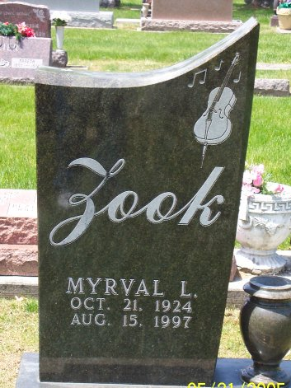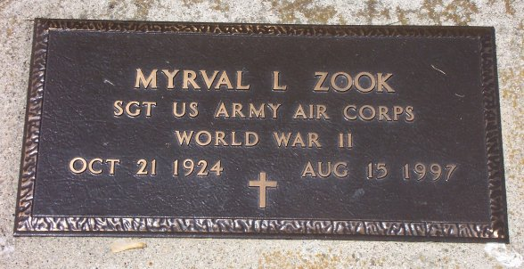
Photo by Bruce Sonner

Myrval L. Zook
in the Indiana, U.S., Death Certificates, 1899-2017
Name Myrval L. Zook
Gender Male
Race White
Marital Status Never Married (Single)
Age 72
Birth Date 21 Oct 1924
Birth Place Miami County, Indiana
Death Date 15 Aug 1997
Death Place Bluffton, Wells, Indiana, USA
Death Registration Date 1997
Father Floyd A. Zook
Mother Polly Myers
Informant Eva Bowman; sister; Craigville, Indiana
Burial August 18, 1997; Elm Grove Cemetery; Bluffton, Indiana

