Michael W. Zook
December 15, 1955 – July 6, 1970

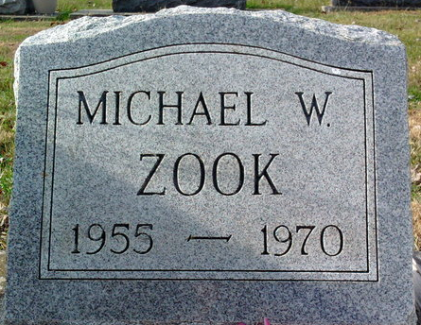
Photo by Thomas Liby

Mike Zook, 14, a son of Mr. and Mrs. Mark Zook of Bluffton, Route 1, will be held Wednesday at the Thoma Funeral Home. The freshman at Southern Wells High School died as a result of a broken neck sustained in an accident 1 ½ miles southwest of Bluffton on Monday.
He was dead on arrival at Clinic Hospital. Burial will be in Elm Grove Cemetery.
Born December 15, 1955, he is survived, in addition to his parents by one sister, Mrs. James (Ruth Ann) Studabaker of Bluffton, three brothers, Kenneth, Ronald, and Frederick, all at home, and his grandparents, Mr. and Mrs. Floyd Zook, also of Bluffton.
Mrs. Zook is the former Betty J. Bollinger.

Bluffton News-Banner, Wells County, Indiana
July 7, 1970

**
Indiana, U.S., Death Certificates, 1899-2017
Name Michael W Zook
Gender Male
Race White
Marital Status Never
Age 14
Birth Date 15 Dec 1955
Birth Place Indiana
Death Date 6 Jul 1970; go-cart/auto accident
Death Place Bluffton, Wells, Indiana, USA
Death Registration Date 1970
Father Mark W Zook
Mother Betty T Bolinger
Informant Mark W. Zook; father; Bluffton, Indiana
Burial July 8, 1970; Elm Grove Cemetery; Bluffton, Indiana

