Mark W. Zook
February 25, 1928 – April 11, 2025

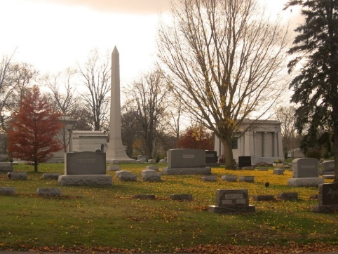
Photo by Tombstoner & Family

Mark W. Zook, 97 of Bluffton, passed away early Friday morning, April 11, 2025, at Stillwater Hospice Home in Fort Wayne.
He was born on February 25, 1928, in New Philadelphia, Ohio to Floyd & Polly (Myers) Zook.
Mark retired after 41 years of managing the C & C Oil Company, Gas Station on Wabash Street. He had previously worked as a truck driver and worked for Ellenberger Brothers Auction Company and Montgomery Ward. He enjoyed working outdoors and spent his free time and retirement at his woods.
On July 29, 1949, in Huntington, Mark and Betty I. (Bollinger) Zook were married. They shared 73 years of marriage before she preceded him in death on March 22, 2023.
Survivors include his children; Kenneth Zook of California, Ron (Sherri) Zook and Fred Zook, both of Bluffton, along with 5 grandchildren, 4 great-grandchildren and 4 great-great-grandchildren.
He is also survived by a sister, Eva Bowman of Craigville.
Mark is preceded in death by his parents, wife Betty a daughter Ruth Ann Bailey, a son, Michael W. Zook and siblings; Richard Zook, Myrval Zook, Elden Zook, Larry Zook and Rosalin McKinnley.
Visitation will be held from 4 to 7 on Monday (April 14, 2025) at the Thoma/Rich, Lemler Funeral Home in Bluffton and for one hour prior to the service. Funeral services will be held at 1: 30 on Tuesday (April 15, 2025) at the funeral home with Barry Crosbie officiating. Burial will follow at Elm Grove Cemetery in Bluffton.

Thoma/Rich Funeral Home, Wells County, Indiana
April 12, 2025

