Floyd A. Zook
June 1, 1897 – February 14, 1984

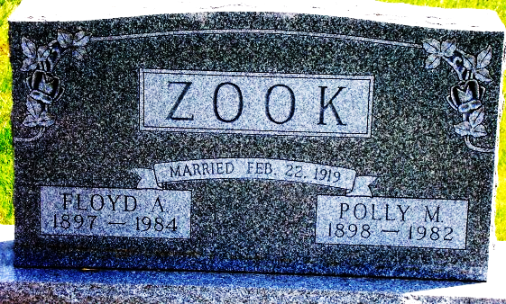
Photo by Bruce Sonner

Floyd A. Zook
in the Indiana, U.S., Death Certificates, 1899-2017
Name Floyd A. Zook
Gender Male
Race White
Marital Status Widowed
Age 86
Birth Date 1 Jun 1897
Birth Place Indiana
Death Date 14 Feb 1984
Death Place Bluffton, Wells, Indiana, USA
Death Registration Date 1984
Father Andrew Zook
Mother Jemina Shrock
Informant Mrs. Eva Bowman; daughter; Craigville, Indiana
Burial February 16, 1984; Elm Grove Cemetery; Bluffton, Indiana

