Pauline Elizabeth (Beckler) Zoll
June 11, 1922 – September 28, 2010

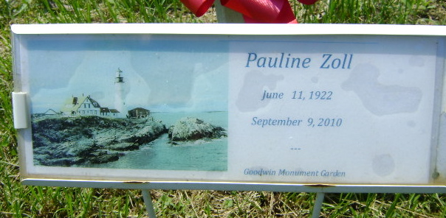
Photo by Bruce Sonner

Pauline Elizabeth Zoll
in the Indiana, U.S., Death Certificates, 1899-2017
Name Pauline Elizabeth Zoll
[Pauline Elizabeth Beckler]
Maiden Name Beckler
Gender Female
Race White
Marital Status Widowed
Age 88
Birth Date 11 Jun 1922
Birth Place Bluffton, Indiana
Death Date 28 Sep 2010
Death Place Warren, Huntington, Indiana, USA
Death Registration Date 2010
Father John W Beckler
Mother Grace Pearson
Informant John Beckler; brother; Bluffton, Indiana
Burial Elm Grove Cemetery; Bluffton, Indiana

