Martha L. (Masterson) Zoll
April 4, 1908 – September 24, 1999

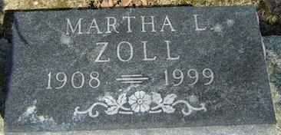
Photo by Bruce Sonner

Services will be at 10 a.m. Tuesday at Goodwin Memorial Chapel for Martha L. Zoll, 91, of Bluffton, who died at 10 p.m. Friday at Meadowvale Care Center. Calling hours are today from 6 to 8 p.m. at the funeral chapel.
A native and lifelong resident of Wells County, Mrs. Zoll was employed 32 years with the former Estey Piano Factory in Bluffton.
She was born April 4, 1908 to George R. and Mary W. Walburn Masterson. She was a member of the Park United Brethren Church.
Surviving are a daughter-in-law, Mrs. Kenneth (Catherine) Zoll-Powell of Altamonte Springs, Fla; a grandchild, Mrs. Dyke (Deborah) Shannon of Sanford, Fla; two great-grandchildren, Staci and Patrick; and one great-grandchild, Ethan. A son, James R. Zoll, died in 1982.
Rev. Jerry Frees will officiate at services and burial will be in Elm Grove Cemetery at Bluffton.

Bluffton News Banner, Wells County, Indiana
September 27, 1999

