James R. Zoll
December 19, 1926 – November 24, 1982

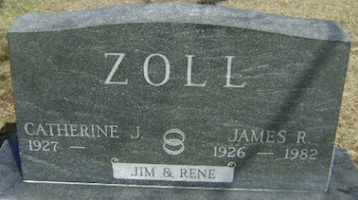
Photo by Bruce Sonner

James R. Zoll
in the Indiana, U.S., Death Certificates, 1899-2017
Name James R. Zoll
Gender Male
Race Caucasian (White)
Marital Status Married
Age 55
Birth Date 19 Dec 1926
Birth Place Indiana
Death Date 24 Nov 1982
Death Place Bluffton, Wells, Indiana, USA
Death Registration Date 1982
Father Robert D. Zoll
Mother Martha L. Masterson
Spouse Rene Schmoll
Informant Rene Zoll; wife; Bluffton, Indiana
Burial November 27, 1982; Elm Grove Cemetery; Bluffton, Indiana

