Catherine J. (Schmoll) Zoll
April 16, 1927 – December 19, 2010

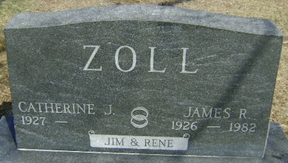
Photo by Bruce Sonner

Catherine 'Rene' Zoll, 83
Catherine "Rene" Zoll, 83, of Altamonte Springs, Fla., a former resident of Bluffton, died at 7:30 p.m. Sunday, Dec. 19, 2010, at Heritage Assisted Living in Sanford, Fla. Mrs. Zoll was a 1945 graduate of Bluffton High School. She retired from the Caylor-Nickel Clinic in 1986. She was a member of the Bluffton American Legion Post 111 Auxiliary.
She was born April 16, 1927, in Peru, Ind., to Charles Schmoll and Madia Royce Schmoll. She married James R. Zoll Sept. 28, 1946, in Bluffton; her husband died Nov. 24, 1982. Survivors include a daughter, Deborah L. (Dyke) Shannon, Sanford, Fla.; a granddaughter, Staci Klinger of New York; a grandson, Patrick J. Shannon of Florida; a great-grandson, Ethan Shannon of Florida; a brother, Charles "Bud" Schmoll of Winter Haven, Fla.; and two sisters, JoAnn (Tom) Huffman of Fort Wayne and Mary Jayne (Lyle) Crandall of Bluffton.
In addition to her parents and her husband, she was preceded in death by two sisters, Rosie Burgess and Susie Schmoll.
Calling will be from 1 to 3 p.m. Thursday, Dec. 30, at the Goodwin Memorial Chapel in Bluffton. A memorial service will be held at the funeral home at 3 p.m. Thursday, Dec. 30. Burial will be in the Elm Grove Cemetery.
Preferred memorials are to the Hospice of the Comforter, 480 W. Central Parkway, Altamonte Springs, Fla. 32714.

Goodwin Funeral Home, Wells County, Indiana
December 20, 2010

