Theodore Bronton Zirkle
May 23, 1852 – March 29, 1926

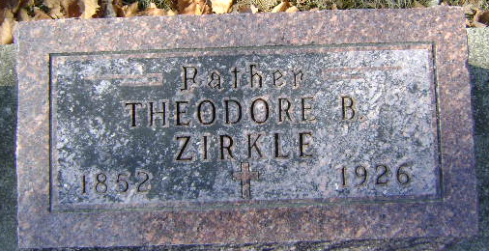
Photo by Bruce Sonner

Theodore Bronton Zirkle
in the Indiana, U.S., Death Certificates, 1899-2017

Name Theodore Bronton Zirkle
Gender Male
Race White
Marital Status Widowed
Age 73
Birth Date 23 May 1852
Birth Place Ohio
Death Date 29 Mar 1926
Death Place Wells, Indiana, USA
Death Registration Date 1926-1927
Father Cornelius Zirkle
Mother Unknown
Spouse Lydia A Houser
Informant Carry Zirkle; Bluffton, Indiana
Burial March 31, 1926; Elm Grove Cemetery

