Mary M. Zirkle
July 28, 1915 – September 9, 2002

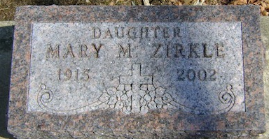
Photo by Bruce Sonner

Mary M Zirkle
in the Indiana, U.S., Death Certificates, 1899-2017
Name Mary M Zirkle
Gender Female
Race White
Marital Status Single
Age 87
Birth Date 28 Jul 1915
Birth Place Wells County, Indiana
Death Date 9 Sep 2002
Death Place Ossian, Wells, Indiana, USA
Death Registration Date 2002
Father Cary Zirkle
Mother Effie Studebaker
Informant Ken Yake; nephew; Bluffton, Indiana
Burial September 11, 2002; Elm Grove Cemetery; Bluffton, Indiana

