Lydia A. (Houser) Zirkle
August 17, 1857 – June 28, 1919

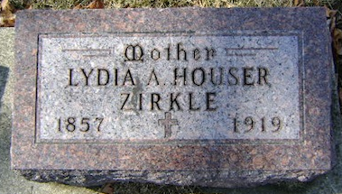
Photo by Bruce Sonner

Suffers Stroke of Paralysis
(Special to the News)
BLUFFTON, Ind., June 30. – Mrs. Lydia Zirkle suffered a stroke of paralysis Thursday at her home on East Market Street, and is in a serious condition.
Mrs. Theodore Zirkle Dead
(Special to the News)
BLUFFTON, Ind., June 30. – Mrs. Theodore Zirkle was claimed by death Saturday, after she had been stricken with paralysis two days previous. She was born in Ohio, the daughter of Mr. and Mrs. Fred Houser and was 61 years old at the time of her death.

Fort Wayne News and Sentinel, Allen County, Indiana
Monday, June 30, 1919
Page 22
**
Indiana, Death Certificates, 1899-2011
Name: Lydia Ann Zirkle
[Lydia Ann Houser]
Gender: Female
Race: White
Age: 61
Marital status: Married
Birth Date: 17 Aug 1857
Birth Place: De Kalb Co, Indiana
Death Date: 28 Jun 1919
Death Place: Bluffton, Wells, Indiana, USA
Father: William Houser
Mother: Mary Ann Merica
Spouse: Theodore Brouson Zirkle
Informant: Family; Bluffton, Indiana
Burial: June 30, 1919; Elm Grove Cemetery

