Effie E. (Studebaker) Zirkle
October 30, 1891 – October 11, 1973

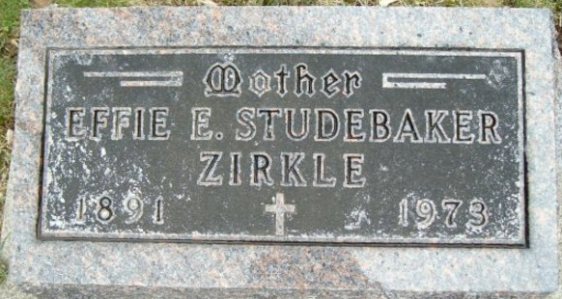
Photo by Smalltown

Mrs. Effie Zirkle Dies at Age of 81
Widow of Cary Zirkle, Mrs. Effie E. Zirkle, 81, of 706 Melching Dr., Ossian, died at 2:45 a.m. today at Meadowvale Care Center after having been in failing health five months.
Born Oct. 30, 1891 in Wells County, she was a daughter of George and Sarah Huffman Studebaker. Her marriage to Mr. Zirkle, who died in 1943, took place Sept. 15, 1912 at the Six Mile Church.
Mrs. Zirkle, a member of the Church of Christ, was a retired cook at the Lancaster School.
Surviving is a son, George of Elkhart; two daughters, Miss Mary Zirkle of Ossian and Mrs. Noah (Martha) Yake of Craigville Route 1; two sisters, Mrs. Nina Miller and Mrs. Dwight (Alta) Maddux, both of Bluffton, five grandchildren and seven great-grandchildren.
Friends may call after 7 p.m. today at the Thoma-Rich Funeral Home, where services will be at 2:30 p.m. Saturday. Rev. Edward Geans will officiate and burial will be in the Elm Grove Cemetery.

News Banner, Wells County, Indiana
Thursday, October 11, 1973

