Cary Oris Zirkle
May 6, 1892 – December 28, 1943

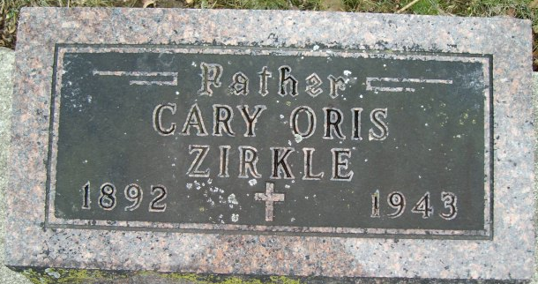
Photo by Smalltown

Cary Zirkle Died of Heart Seizure
Death Occurs at Home of Decedent One-Half Mile South of Kingsland
Cary Zirkle, 51, died at 7:45 p.m. Tuesday at his home one-half mile south of Kingsland. He had been ill only one day, following a heart attack.
He was an employee of the International Harvester company at Fort Wayne.
Mr. Zirkle was born May 6, 1892 in Adams County, a son of Theodore and Ann Houser Zirkle, and resided most of his life in Adams and Wells counties. His marriage in 1912 in Wells County was to Effie Studabaker, who survives.
Surviving besides the widow are a son, George Zirkle, near Bluffton; two daughters, Miss Mary Zirkle, at home, and Mrs. Noah Yake, near Craigville, and four grandchildren. A brother is deceased.
The grandchildren are Eddie, Billie and Keith Zirkle and Freddie Kay Yake.
The body will be removed late this evening from the Jahn Funeral Home and taken to the residence. Funeral services will be held at 2 p.m. Saturday at the Kingsland Methodist Church in charge of Rev. Charles Moore, assisted by Rev. Paul Mehrens. Burial will be in the Elm Grove Cemetery.

News Banner, Wells County, Indiana
Wednesday, December 29, 1943

