Nina H. (Shady) Zimmerman
September 24, 1910 – September 5, 1989

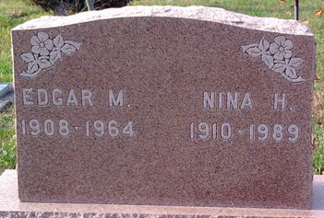
Photo by Thomas Liby

Nina Zimmerman, 78, died unexpectedly at noon Tuesday in Adams County Memorial Hospital. She was a resident of Lakeside Manor Nursing Home.
Born September 24, 1910 in Tocsin, she was the daughter of Albert and Julia (Sovine) Shady. She married Edgar M. Zimmerman in March of 1928; he died February 23, 1964.
She was formerly employed at Niblicks Department Store as a sales clerk and was a member of St. Luke's United Church of Christ. She was also a former member of the Kirkland Ladies Club.
Surviving are two sons, E. Miles Zimmerman, New Haven, and Roland Zimmerman, route 3, Decatur; one daughter, Mrs. Frank (Onalee) Taylor, Bay Village, Ohio; three sisters, Mrs. Mabel Smith and Mrs. Richard (Flossie) Bogner, both of Decatur, and Mrs. Ethel Galbarth (sic), Marion, Ohio; eight grandchildren; and three great-grandchildren. Three brothers are deceased: Dortha, Walter and Larwell Shady.
Funeral services will be 11 a.m. Friday at Haggard & Armes Funeral Home, Rev. Peter Smith officiating. Calling hours are Thursday from 3-5 and 7-9 p.m. Burial will be in Elm Grove Cemetery in Bluffton.
Memorials are to St. Luke's United Church of Christ.

Decatur Daily Democrat, Adams County, Indiana
Wednesday, September 6, 1989

