Martha B. (Osborn) Zimmerman
September 9, 1919 – March 6, 1980

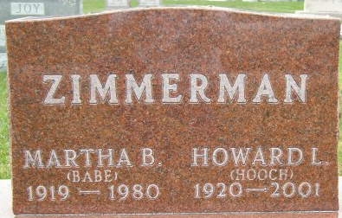
Photo by Thomas Liby

Martha B. Zimmerman
in the Indiana, U.S., Death Certificates, 1899-2017
Name Martha B. Zimmerman
[Martha B. Osborn]
Gender Female
Race White
Marital Status Married
Age 60
Birth Date 9 Sep 1919
Birth Place Indiana
Death Date 6 Mar 1980
Death Place Bluffton, Wells, Indiana, USA
Death Registration Date 1980
Father Charles Osborn
Mother Buleah Folk
Spouse Howard Zimmerman
Informant Howard Zimmerman; Bluffton, Indiana
Burial March 8, 1980; Elm Grove Cemetery; Bluffton, Indiana

