Howard L. Zimmerman
July 5, 1920 – February 12, 2001

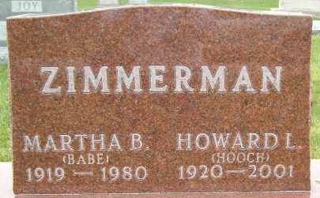
Photo by Thomas Liby

Howard ‘Hooch' Zimmerman, 80
Funeral services for Howard "Hooch" Zimmerman, 80, will be conducted at 2 p.m. Wednesday at Goodwin Memorial Chapel.
Mr. Zimmerman, an employee for many years at Franklin Electric Co., resided at 626 West Arnold St. He died at 2:40 a.m. Monday at Caylor-Nickel Medical Center.
Visitation hours at Goodwin Memorial Chapel are today from 2 to 8 p.m.
Mr. Zimmerman was born in Adams County July 5, 1920 to Fred and Lela Brown Zimmerman. His marriage at Bluffton on July 6, 1952 was to Martha Osborn, who died March 6, 1980.
A brother, Robert Zimmerman of Warren, is the sole survivor.
Burial will be in Elm Grove Cemetery at Bluffton.

News Banner, Wells County, Indiana
Tuesday, February 13, 2001

