Edgar M. Zimmerman
March 9, 1908 – February 23, 1964

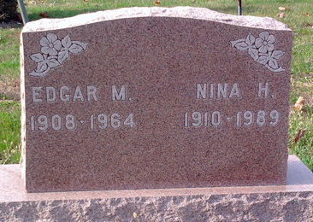
Photo by Thomas Liby

Edgar Zimmerman Dies Last Evening
Edgar M. Zimmerman, 55, lifelong resident of Adams County, died suddenly at 7:50 o'clock Sunday evening at his home, 414 North Second Street. Although he had been in failing health for some time, death was sudden.
He was born in Adams County March 9, 1908, a son of Clint and Della Frye-Zimmerman, and was married to Nina Shady in March of 1928.
Mr. Zimmerman, a salesman for F. McConnell & Sons, was a member of St. Luke's United Church of Christ, and the United Travelers Association.
Surviving are his wife; his mother, Mrs. Della Zimmerman of Fort Wayne; one daughter, Mrs. Frank W. (Onalee) Taylor of Cleveland, O.; two sons, Miles Zimmerman of Fort Wayne, and Ronald Zimmerman, with the U. S. Navy at Norfolk, Va.; one grandchild; one brother Joe Zimmerman of Decatur route 4, and five sisters, Mrs. D. E. (Josephine) Foreman of Decatur, Mrs. Herbert (Berteline) Foreman of Fort Wayne, Mrs. Robert (Catherine) Kiess of Decatur, Miss Virginia Zimmerman and Mrs. Chalmer (Donna) Borne, both of Fort Wayne. One sister is deceased.
Funeral services will be conducted at 2 p.m. Wednesday at the Winteregg-Linn Funeral Home, with the Rev. Robert Oleson officiating. Burial will be in Elm Grove cemetery at Bluffton. Friends may call at the funeral home after 7 p.m. today until time of the services.

Decatur Daily Democrat, Adams County, Indiana
Monday, February 24, 1964

