Trey Robert Zimmer
February 1, 2002 – February 24, 2003

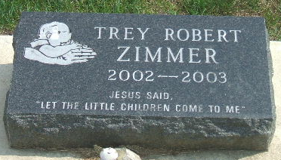
Photo by Thomas Liby

Trey Robert Zimmer, Age 1

Trey Robert Zimmer died at 3:05 pm Monday, February 24 at his home with his family at 202 ½ West Market Street. He was age one year and 24 days.
He was born in Fort Wayne February 1, 2002 to Jeremy L and Shannon Elasser Zimmer, who survives, and who are members of the Sonlight Wesleyan Church at Bluffton.
Surviving also are a brother, Kobe James, at home; the grandparents, Mr. and Mrs. Jim (Cheryl) Zimmer of Bluffton and Mr. and Mrs. Jim (Vickie) Elasser of Peoria, Illinois; the great grandparents and numerous aunts and uncles.
Services will be held at 2 pm Saturday at the Sonlight Wesleyan Church with Rev. Robert Burchell officiating. Burial will be at the Garden of Chimes in Elm Grove Cemetery at Bluffton. Calling hours at the Thoma/Rich Hewitt & Chaney Funeral Home will be Thursday from 5 to 8 pm and Friday from 2 to 8 pm and at the church Saturday for one hour prior to services.
Memorials to the donor’s choice.

Bluffton News-Banner, Wells County, Indiana
February 25, 2003

