LeRoy Martin “Whitey” Ziebart
May 1, 1916 – October 16, 1980

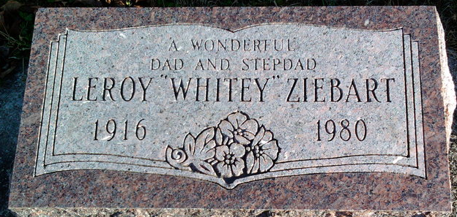
Photo by Thomas Liby

LeRoy M. “Whitey” Ziebart

LeRoy M. Ziebart, 64, of Route 2, Decatur, Indiana, formerly of South Bend, died at 9:55 am Thursday in the Davis Nursing Home, Bluffton, Indiana after an illness of several months.
He was a former Studebaker Corp. employee and worked as a pipe fitter at International Harvester, Fort Wayne.
Born May 1, 1916, in Wellington, Illinois, he had lived in South Bend for several years. On August 16, 1968, he married Ann Ginger, who survives.
Also surviving are three daughters, Mrs. Beth Reinhart of Decatur, Mrs. Linda Anderson of Philadelphia and Mrs. Darlene Speck of Michigan City; five stepdaughters, Mrs. Beverly Nagy of Mishawaka, Mrs. Phyllis Gonzalez of Poneto, Indiana, Mrs. Sharon Gonzalez of Decatur, Mrs. Dena Schaffer of Butler, Indiana and Mrs. Debbie Wiegmann of Decatur; a stepson, Billy Ginger of Poneto; six grandchildren; a brother, Wilbur of Ellington, New York and a stepbrother, LaVern Shipley of South Bend.
Services will be at 3 pm Sunday in the St. Paul Lutheran Church, Preble, Indiana of which he was a member. Rev. Jeffrey Kinery, pastor, will officiate. Burial will be in Elm Grove Cemetery, Bluffton. Friends may call after 7 pm today, all day Saturday and until 12:30 pm Sunday in the Zwick Funeral Home, Decatur and from 1:30 to 3 pm Sunday in the church.

Unknown source

**
Indiana, U.S., Death Certificates, 1899-2017
Name Leroy Martin Ziebart
Gender Male
Race White
Marital Status Married
Age 64
Birth Date 1 May 1916
Birth Place Illinois
Death Date 16 Oct 1980
Death Place Bluffton, Wells, Indiana, USA
Death Registration Date 1980
Father Ernest Martin Ziebart
Mother Bessie Moree Hamilton
Spouse Ann Ginger
Informant Mrs. Ann Ziebart; Decatur, Indiana
Burial October 19, 1980; Elm Grove Cemetery; Bluffton, Indiana

