Nicholas Mark Zello
April 25, 1927 -

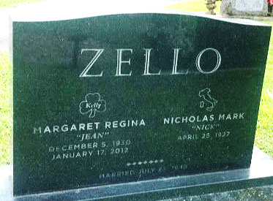
Photo by SMMR

