Nicholas Mark Zello
April 25, 1927 – January 15, 2026

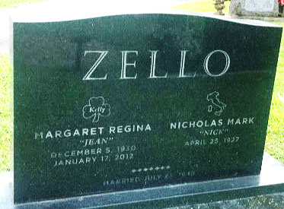
Photo by SMMR

After 98 years of making spaghetti, cheating at cards, driving too fast, general tinkering, happily being the butt of the joke, and getting bossed around (“Hey Hon”) by his wife of 62 years, Nick Zello passed away peacefully in the early hours of January 15, 2026.
Nick was born to Angelo and Mary Grace (Alteri) Zello on April 25,1927 on the family's kitchen table in Sayre, PA. Nick was the youngest of seven. He is predeceased by his parents, wife, brothers, Michael, Giuseppe (“Pep”), Patricio (“Putz”), and sisters Clementine, Susan, and Lucia. Nick served his country during World War II. He was a Navy Signalman on the USS Pocono.
During this time, he earned the nickname “Pretty Boy Zello”. Upon returning from the war, he went back to finish high school where he met the love of his life, Jean Kelly. Nick told Jean he was going to give her a nickel to call him when she turned 16 and a bag of rocks to keep the wolves away. Jean waited until she was 16 and sent Nick a card telling him that she was all out of rocks, letting him know it was well past time for him to ask her out. Nick and Jean were wed on July 23, 1949. They had their first child in 1951 and six more followed over the next 19 years: Mark, Joe, Peg, Colleen, Nick, Ed, and John. A devoted father, Nick never missed a chance to support his kids in all their endeavors.
Nick was well known for his triple beer move; while in the kitchen he would drink one beer, pour another into his glass, and bring a full beer out in the bottle. He was a man of great patience and few words, who mastered the art of expressing his emotions through sighs, throat-clearing, and the occasional “Bah!”. He could frequently be found relaxing in his chair, beer at his side, and Blue Bloods on full blast with the captions on. Nick was a lifelong lover of dogs…and Tom Selleck; he would light up when discussing either one. Nick spent countless hours driving to see his kids, repainting the walls white (“Hey Hon”), going to the grocery store multiple times a day, flip-flopping the dining room and living room furniture (“Hey Hon”), playing Hand and Foot (always keeping score, always winning…hmmmm), making people food or getting them snacks (“Hey Hon”), soaking up the sun, and cheating on crossword puzzles. He could cook, he could sew, he could return items to the store that had been used for years, he could speak an old Italian dialect that drew gasps when he visited his parents’ village in Italy.
In addition to his seven kids, he is survived by lots of grandkids, a few great-grandkids to whom he was known as “Old Grandpa”, and, most importantly, several granddogs and great-granddogs.
The family would like to express their heartfelt appreciation to the staff at The Springs of Lafayette and River Terrace of Bluffton for the compassion and care shown to Nick during his years at those facilities.
A private celebration of life will be held at a later date. Nick was a cool guy; in lieu of flowers or donations, go pet a dog, listen to the Eagles, drink a beer, or watch some Blue Bloods with the volume all the way up. He’d planned to make it to 100, but his Irish Honey let him know that she ran out of rocks again… “Hey Hon”.

Thoma/Rich Funeral Home, Wells County, Indiana
January 20, 2026

