Margaret Regina “Jean”(Kelly) Zello
December 5, 1930 – January 17, 2012

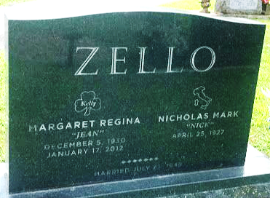
Photo by SMMR

Margaret R. "Jean" Zello 81 of Bluffton passed away on Tuesday morning, January 17, 2012, at Lutheran Hospital in Fort Wayne. Calling Hours will be held from 3 to 7 on Thursday at the Thoma/Rich, Chaney & Lemler Funeral Home in Bluffton with a Rosary Service at 7. Mass of the Christian Burial will be held at 10 a.m. Friday, January 20, 2012, at St. Joseph Catholic Church in Bluffton with calling one hour prior to mass. Burial will follow at the Garden of Chimes located in Elm Grove Cemetery in Bluffton.
Memorials may be made in Jean's memory to St. Joseph Catholic Church.

Thoma/Rich Funeral Home
January 18, 2012

**
Indiana, U.S., Death Certificates, 1899-2017
Name Margaret R. Zello
Maiden Name Kelly
Gender Female
Race White
Age 81
Birth Date 5 Dec 1930
Birth Place Pittston, Pennsylvania
Death Date 17 Jan 2012
Death Place Fort Wayne, Allen, Indiana, USA
Death Registration Date 2012
Father Edward Kelly
Mother Margaret Maughan
Spouse Nick M. Zello
Informant Nick Zello; spouse; Bluffton, Indiana
Burial Elm Grove Cemetery; Bluffton, Indiana
Certificate Number 002222

