Frances L. (Hall) Zalac
June 10, 1917 – July 7, 2006

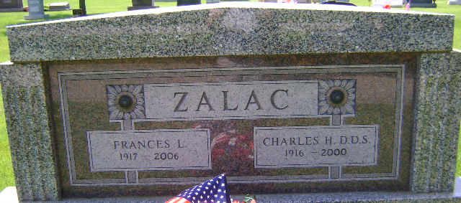
Photo by Bruce Sonner

Frances Louise Zalac, 89, died at Christian Care Retirement Community at 9:45 a.m. Friday, July 7, 2006. Death was attributed to natural causes. Mrs. Zalac was the widow of Dr. Charles H. Zalac, a dentist at Caylor-Nickel Clinic for 31 years. They were married in Indianapolis on Nov. 4, 1938. He preceded her in death June 23, 2000.
Mrs. Zalac was born June 10, 1917, in Indianapolis to Ellis B. and Cleo M. Hall. She attended Butler University and was a member of Pi Beta Phi and Psi Iota Xi sororities. A resident of Wells County since 1947, she was a member of the First United Methodist Church in Bluffton.
Survivors include a son, Charles Allan Zalac of Bluffton, a daughter, Mrs. Larry (Sharon) Bachelor of Blythewood, S.C.; six grandchildren; 12 great-grandchildren; and four great-great-grandchildren. Two sisters, Viola Beeby and Cebie Carroll, preceded her in death.
Services will be at 11 a.m. Wednesday at Thoma/Rich, Hewitt & Chaney Funeral Home, Bluffton. Calling at the funeral home is from 2 to 8 p.m. Tuesday and one hour prior to services on Wednesday. Entombment will take place in the Zalac Family Mausoleum at Elm Grove Cemetery.
Preferred memorials are to Caylor-Nickel Foundation, Christian Care Retirement Community or Family Hospice of Northeast Indiana.

Thoma/Rich Funeral Home, Wells County, Indiana
July 8, 2006

