Elsie Louise (Toegnes) Zalac
October 10, 1894 – May 6, 1950

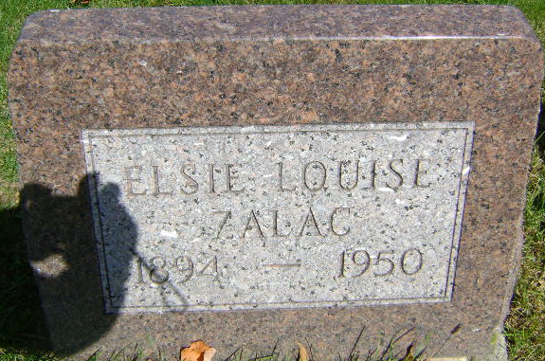
Photo by Bruce Sonner

Mrs. Elsie Zalac Services Tomorrow
Mrs. Elsie Louise Zalac, 54, mother of two doctors, will be buried tomorrow at 2 pm in the Elm Grove Cemetery, Bluffton. Services will be held at 10 am in Flanner & Buchanan Mortuary here. Mrs. Zalac died Saturday in her home, 2916 N New Jersey St, after an extended illness.
A native of Ft Wayne, Mrs. Zalac had lived in Indianapolis for 36 years. She was a member of the Lutheran Church of Our Redeemer.
Survivors are the husband, Charles W Zalac; the two sons, Dr. Charles Henry Zalac, Bluffton, and Dr. Donald A Zalac, Indianapolis; two sisters, Mrs. Waldemar Fortriede and Mrs. Esther Hartzog, Ft Wayne, and two brothers, Albert Toenges, Lansing, Mich, and Harry Toenges, Ft Wayne.

The Indianapolis News, Marion County, Indiana
May 8, 1950

**
Indiana, U.S., Death Certificates, 1899-2017
Name Elsie Louise Zalac
[Elsie Louise Toenges]
Gender Female
Race White
Marital Status Married
Age 55
Birth Date 10 Oct 1894
Birth Place Fort Wayne, Indiana
Death Date 6 May 1950
Death Place Indianapolis, Marion, Indiana, USA
Father Henry Toenges
Mother Elsie Toenges
Spouse Charles Walter Zalac
Informant Charles Zalac; Bluffton, Indiana
Burial May 9, 1950; Elm Grove Cemetery; Bluffton, Indiana

