Donald A. Zalac, MD
August 28, 1923 – April 20, 2019

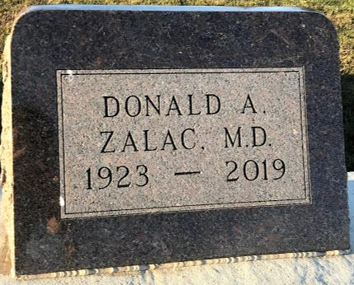
Photo by SMMR

Donald A. Zalac, M.D. was born August 28, 1923 in Indianapolis. His parents were Mr. & Mrs. Charles W. Zalac.
He was a graduate and class president at Butler University. At the age of 21, he was the youngest ever graduate of Indiana University School of Medicine. He served an internship at Indianapolis City Hospital (now Wishard Hospital), followed by two years as a Captain in the Army Medical Corp. He returned to Wishard Hospital for a Fellowship in Internal Medicine, followed by a residency in Radiology, the last three months of which he was the acting Director of Radiology at Wishard Hospital. He declined an offer to continue in that position to join Dr. C. Robert Plank in 1952 in the Michigan City practice of Radiology. For a few years, in addition to serving as radiologists at the Michigan City Hospitals, they were also itinerate radiologists at the Knox and Rochester, Indiana hospitals. They later closed their private office in favor of developing a new Radiology Department at St. Anthony Hospital which included, at that time, the only Cobalt Therapy in LaPorte County. During his medical career, he treated thousands of cancer patients. In the 1970s nearly all cancer chemotherapy in the Michigan City region was under his care.
He was a member of the American Medical Association, a Fellow of the American College of Radiology, a counselor of the Indiana Chapter of the Radiology Society of North America, a Diplomat of the American College of Nuclear Medicine and a charter member of the Chicago Nuclear Society. His hobbies were related to the outdoors.
For years, he enjoyed vacations at this log cabin with acreage on a lake in northern Wisconsin. His greatest non-medical interest was his 175-acre farm near Bendix Park in northern Indiana. With his labor and conservation practices, he converted it from depleted soil to lush meadows, woods and wetlands, supporting abundant wildlife. He particularly enjoyed hosting members of St. Paul Lutheran Church for the change of colors at the farm in the autumn for several years. He was a 62-year member of St. Paul Lutheran Church. Since retirement in 1979, his time was divided between his farm, home in Michigan City and residence in Venice, Florida.
He was preceded in death by his parents: Mr. & Mrs. Charles W. Zalac and his older brother: Dr. Charles H. Zalac. He is survived by his ex-wife: Beverly Zalac; niece: Sharon Bachelor of Columbia, South Carolina and nephew: Charles A. Zalac of Bluffton, IN.
Those wishing to pay their respects are invited to Geisen-Carlisle Funeral Home located at 613 Washington St. Michigan City, IN 46360 on Friday, April 26, 2019 from 3:00 to 7:00 PM CST and on Saturday, April 27, 2019 at St. Paul Lutheran Church 818 Franklin St. Michigan City, IN from 10:00 AM to time of service.
Funeral Service will be held on Saturday, April 27, 2019 11:00 AM at St. Paul Lutheran Church with Pastor Mark Reshan officiating.
Private family burial will be held at a later date in Elm Grove Cemetery, Bluffton, Indiana.
Unknown source

**
Web: Sarasota County, Florida, U.S., Obituary Index, 1867-2021
Name Dr Donald A. Zalac
Birth Date 28 Aug 1923
Birth Place Indianapolis, Ind.
Military service US Army Medical Corp.
Death Date 20 Apr 2019
Death Place Florida, USA
First Obituary Date 25 Apr 2019
Obituary Place Sarasota, Florida, USA
Spouse Beverly-X
Newspaper Sarasota Herald-Tribune
Notes He Was an Out Standing Radiologist. Services At St. Paul Lutheran Church. Private Family Burial Will Be At A Later Date in Elm Grove Cemetery, Bluffton, Indiana.
**
Dr. Donald Akbert Zaloc from tree angela iannucilli family tree
Birth 28 Aug 1923 Indianapolis, Marion, Indiana, USA
Residence 1950 Indianapolis, Marion, Indiana, USA
Death 20 Apr 2019
Father Charles Walter Zaloc (1889-1987)
Mother Elsie Louise Toenges (1894-1950)

