Charles W. Zalac
July 1, 1889 – July 18, 1987

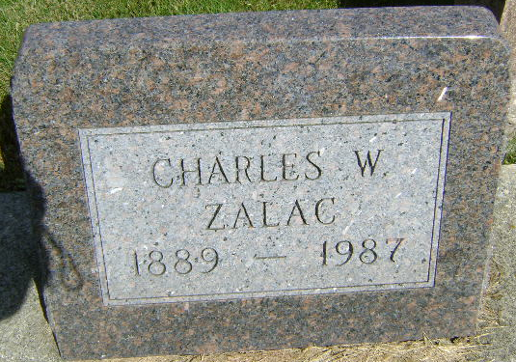
Photo by Bruce Sonner

Charles W Zalac
in the Indiana, U.S., Death Certificates, 1899-2017
Name Charles W Zalac
Gender Male
Race White
Marital Status Widowed
Age 98
Birth Date 1 Jul 1889
Birth Place Austria
Death Date 18 Jul 1987
Death Place Berne, Adams, Indiana, USA
Death Registration Date 1987
Parents Unknown
Informant Dr. Charles Zalac; Ft. Myers, Florida
Burial July 22, 1987; Elm Grove Cemetery; Bluffton, Indiana
**
Michigan, U.S., Marriage Records, 1867-1952
Name Charles Zalac
Gender Male
Race White
Age 24
Birth Date abt 1889
Birth Place Austria
Marriage Date 14 Aug 1913
Marriage Place Hillsdale, Hillsdale, Michigan, USA
Residence Place Muncie, Indiana
Father George Zalac
Mother Mary Noyak
Spouse Elsie Louise Toenges
Record Number 8059

