Charles H. Zalac, D.D.S.
June 16, 1916 – June 23, 2000

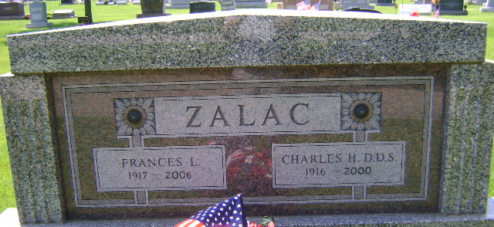
Photo by Bruce Sonner

Dr. Charles H. Zalac, DDS, 84, of Bluffton, a longtime member of the American Dental Association, died Friday, June 23, 2000, at Christian Care Retirement Community.
The Indianapolis native retired from practice in 1985 after 47 years of service, and had practiced in Fort Wayne for three years, at Caylor Nickel Clinic for 31 years, and continued practice as a staff dentist at Shellpoint Village Retirement Center in Fort Myers, Fla. He was a World War II Army veteran serving in the Dental Corps.
Surviving are his wife of 51 years, Frances L.; a daughter, Sharon Bachelor of Blythewood, S.C.; a son, Charles A. of Bluffton; a brother, Dr. Donald A. of Michigan City; six grandchildren; eight great-grandchildren; and one great-great-grandchild.
News-Sentinel, Allen County, Indiana
June 24, 2000

**
Indiana, U.S., Death Certificates, 1899-2017
Name Charles H. Zalac
Gender Male
Race White
Marital Status Married
Age 84
Birth Date 16 Jun 1916
Birth Place Indianapolis, Indiana
Death Date 23 Jun 2000
Death Place Bluffton, Wells, Indiana, USA
Death Registration Date 2000
Father Charles W. Zalac
Mother Elsie Toenges
Spouse Frances L. Hall
Informant Frances Zalac; wife; Bluffton, Indiana
Burial June 27, 2000; Elm Grove Cemetery; Bluffton, Indiana

