Eva F. (McLeod) Zackmire
April 18, 1894 – July 8, 1952

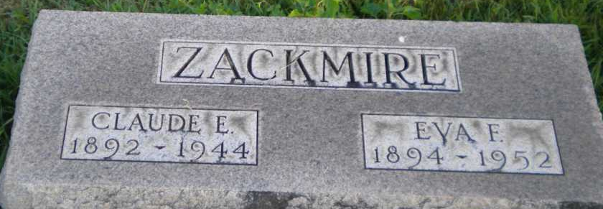
Photo by PLGS

Eva F Zackmire
in the Indiana, U.S., Death Certificates, 1899-2017
Name Eva F Zackmire
Gender Female
Race White
Marital Status Widowed
Age 58
Birth Date 18 Apr 1894
Birth Place Bluffton, Indiana
Death Date 8 Jul 1952
Death Place Portland, Jay, Indiana, USA
Death Registration Date 1952
Father John Mc Leod
Mother Cora Matson
Informant Mrs. Eugene Romack; Portland, Indiana
Burial July 10, 1952; Elm Grove Cemetery; Bluffton, Indiana

