Claude Esten Zackmore
November 21, 1892 – February 25, 1944

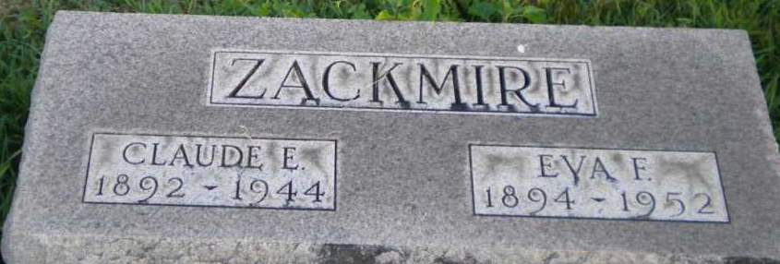
Photo by PLGS

Claude E. Zackmire
in the Illinois, U.S., Deaths and Stillbirths Index, 1916-1947
Name Claude E. Zackmire
Death Date 25 Feb 1944
Death Place Cook County, Illinois
Gender Male
Father Name William Zackmire
Mother Name Abigail Gay
Spouse Name Eva Zackmire
FHL Film Number 1983614
**
Indiana, U.S., Marriages, 1810-2001
Name Claude Esten Zackmire
Gender Male
Race White
Age 27
Event Type Marriage Registration (Marriage)
Birth Date 21 Nov 1892
Birth Place Fountain, Indiana
Marriage Date 26 Nov 1919
Marriage Place Indiana, United States
Residence Place Bluffton, Indiana
Father William Watkins Zackmire
Mother Malissa Abigal Day
Spouse Eva Fray Mcleod
Page 105

