William Walker Yule
April 27, 1912 – December 13, 2006

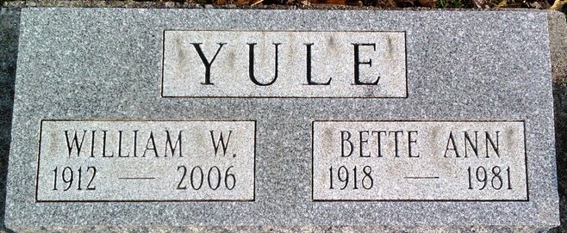
Photo by Thomas Liby

A former resident of Bluffton, William Walker Yule, 94, died Dec. 13, 2006 in Muskegon, Mich. Born April 27, 1912 in Calgary, Alberta, Canada to William and Mary Maude (Davidson) Yule, he moved to Bluffton in 1948 and resided on Marion Street until 1994 when he moved to Wolf Lake, Mich.
During his residency in Bluffton, he worked for Johns-Manville and sold building supplies to various lumber yards. He was a member of the First Methodist Church, Toastmasters and the Elks Lodge.
He was preceded in death by his first wife, Bette Ann (Hilton) Yule in 1981. On Dec. 9, 1983, he married the former Evelyn (Benest) Kann of Wolf Lake, who survives along with two children, Gay Ann (Chip) Saunders of Morganton, N.C., and Roger Hilton Yule of Buffalo Grove, Ill. Also surviving are four stepchildren, Kathy Kann Tuttle, Cindy Kann Skok, Jan Kann Ames and Jack Kann all from the Muskegon, Mich., area; five grandchildren, one great grandchild, 13 step grandchildren and 23 step great grandchildren.
Burial services will be held in the spring at Elm Grove Cemetery in Bluffton.

Unknown source

