Bette Ann (Hilton) Yule
April 23, 1918 – December 21, 1981

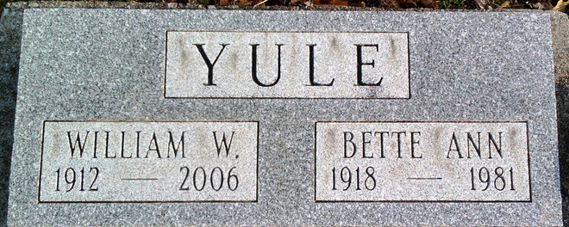
Photo by Thomas Liby

Bette Ann Yule
in the Indiana, U.S., Death Certificates, 1899-2017
Name Bette Ann Yule
[Bette Ann Hilton]
Gender Female
Race White
Marital Status Married
Age 63
Birth Date 23 Apr 1918
Birth Place Illinois
Death Date 21 Dec 1981
Death Place Bluffton, Wells, Indiana, USA
Death Registration Date 1981
Father Glen Hilton
Mother Helen Gast
Spouse William Yule
Informant William Yule; Bluffton, Indiana
Cremation December 23, 1981; Meeks Crematory; Muncie, Indiana

