Ruth (Comer) Young
February 10, 1903 – December 19, 1958

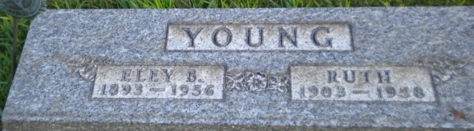
Photo by PLGS

Ruth Young
in the Indiana, U.S., Death Certificates, 1899-2017
Name Ruth Young
[Ruth Comer]
Gender Female
Race White
Marital Status Widowed
Age 55
Birth Date 10 Feb 1903
Birth Place Winslow, Indiana
Death Date 19 Dec 1958
Death Place Bluffton, Wells, Indiana, USA
Death Registration Date 1958
Father William Comer
Mother Eliza Hopkins
Informant Michael Young; son; North Carolina
Burial December 22, 1958; Elm Grove Cemetery; Bluffton, Indiana

