Nettie May (Gilbert) Young
February 19, 1888 – March 14, 1978

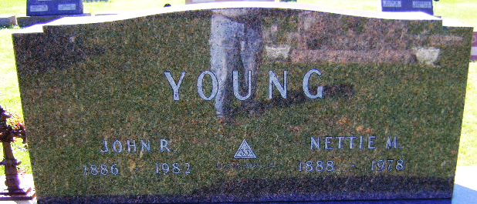
Photo by Bruce Sonner

Nettie May Young
in the Indiana, U.S., Death Certificates, 1899-2017
Name Nettie May Young
[Nettie May Gilbert]
Gender Female
Race White
Marital Status Married
Age 90
Birth Date 19 Feb 1888
Birth Place Indiana
Death Date 14 Mar 1978
Death Place Bluffton, Wells, Indiana, USA
Death Registration Date 1978
Father Philip H Gilbert
Mother Lucinda Raver
Spouse John R Young
Informant Ival Young; Bluffton, Indiana
Burial March 16, 1978; Elm Grove Cemetery; Bluffton, Indiana

