John Raymond Young
August 30, 1886 – April 9, 1982

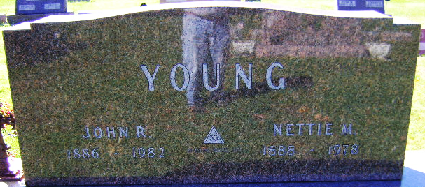
Photo by Bruce Sonner

John Raymond Young from tree Dean Family Tree
Birth 30 Aug 1886 Uniondale, Wells, Indiana, USA
Death 9 Apr 1982 Bluffton, Wells, Indiana, USA
Father John Adam Young (1853-1936)
Mother Readocia Rosetta Harnish (1855-1901)
Spouse Nettie May Gilbert (1888-1976)

