Ival L. Young
October 2, 1907 – February 7, 1995

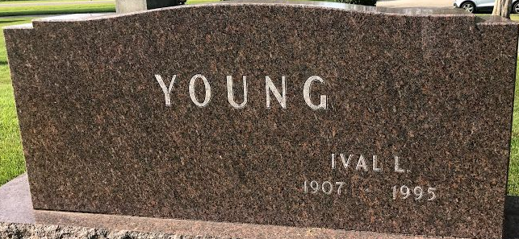
Photo by SMMR

Ival L Young
in the Indiana, U.S., Death Certificates, 1899-2017
Name Ival L Young
Gender Male
Race White
Marital Status Married
Age 87
Birth Date 2 Oct 1907
Birth Place Bluffton, Indiana
Death Date 7 Feb 1995
Death Place Bluffton, Wells, Indiana, USA
Death Registration Date 1995
Father John R Young
Mother Nettie Gilbert
Spouse Evah Green
Informant Bonnie Caston; step-daughter; Decatur, Indiana
Burial February 10, 1995; Elm Grove Cemetery; Bluffton, Indiana

