Eley Bud Young
June 10, 1893 – April 1, 1956

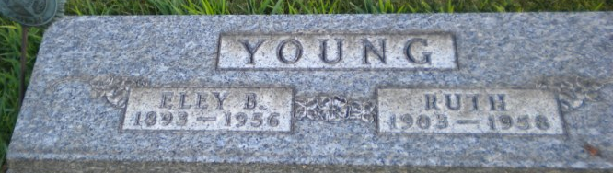
Photo by PLGS

Eley Bud Young from tree My Family Tree
Birth 10 Jun 1893 Rockport, Spencer, Indiana, USA
Residence 1950 Bluffton, Wells, Indiana, USA
Death 1 Apr 1956
Father John A Young (1860-1939)
Mother Elizabeth Woolen (1869-1939)
Spouse Ruth Comer (Born 1904)

