Thomas Earl Yarbrough
July 2, 1878 – September 22, 1921

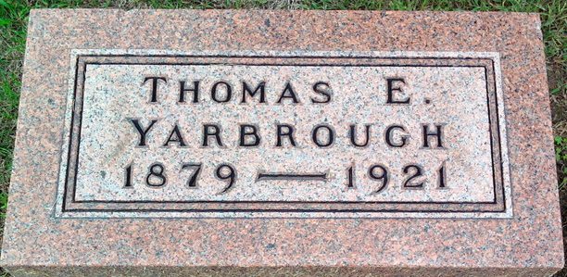
Photo by Thomas Liby

Thomas E Garbrough
in the Indiana, U.S., Death Certificates, 1899-2017
Name Thomas E Yarbrough
Gender Male
Race White
Marital Status Married
Age 42
Birth Date abt 1879
Birth Place Missouri
Death Date 22 Sep 1921
Death Place Ind, Henry, Indiana, USA
Death Registration Date 1921
Father Frank Yarbrough
Mother Belle Leach
Spouse Mrs. Thomas E Yarbrough
Informant C. A. Marsh; New Castle, Indiana
Burial September 24, 1921; Bluffton, Indiana

**
Indiana, U.S., Marriages, 1810-2001
Name Thomas Earl Yarbrough
Gender Male
Race White
Age 28
Event Type Marriage Registration (Marriage)
Birth Date 2 Jul 1878
Birth Place Marion, Indiana
Marriage Date 2 May 1907
Marriage Place Indiana, United States
Residence Place Bluffton, Indiana
Father Frank Yarbrough
Mother Isabella Leach
Spouse Mabel Virginia Rose
Page 56

