Mabel Virginia (Rose) Yarbrough
September 4, 1885 – March 14, 1984

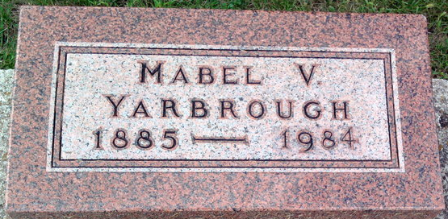
Photo by Thomas Liby

Mabel Yarbrough
in the Indiana, U.S., Death Certificates, 1899-2017
Name Mabel Yarbrough
Gender Female
Race White
Marital Status Widowed
Age 98
Birth Date 4 Sep 1885
Death Date 14 Mar 1984
Death Place Portland, Jay, Indiana, USA
Death Registration Date 1984
Parents Not listed
Informant Catherine Bennett; Citizens Bank; Portland, Indiana
Burial March 19 1984; Elm Grove Cemetery; Bluffton, Indiana
**
Indiana, U.S., Marriages, 1810-2001
Name Mabel Virginia Rose
Gender Female
Race White
Age 21
Event Type Marriage Registration (Marriage)
Birth Date 4 Sep 1885
Birth Place Stulton, Pennsylvania
Marriage Date 2 May 1907
Marriage Place Indiana, United States
Residence Place Bluffton, Indiana
Father Samuel Rose
Mother Anna Irene Carey Rose
Spouse Thomas Earl Yarbrough
Page 56

