Noah F. Yake
January 1, 1919 – March 21, 2003

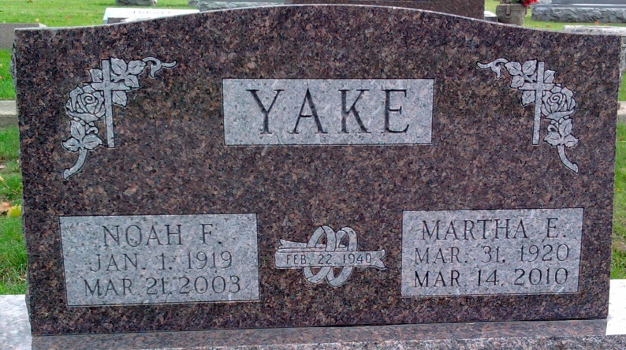
Photo by Thomas Liby

Noah F. Yake, 84

A lifelong Craigville area farmer and retired rural mail carrier, Noah F. Yake, 84, died at 9:25 p.m. Friday at Christian Care Retirement Center in Bluffton following an extended illness.
Mr. Yake, who had resided at Christian Care since 1999, was a former member of the Lancaster Township, Wells County, School Board and a graduate of the Kirkland High School in Adams County. He had retired in 1980 after 36 years as a mail carrier for the U.S. Postal Service. He was member of the Pleasant Dale Church of the Brethren and, with his wife, Martha, was a volunteer docent at the Fort Wayne Children’s Zoo for 10 years.
He was born in Wells County Jan. 1, 1919, a son of Lewis E. and Della Frauhiger Yake. His marriage to Martha Zirkle, who survives, took place Feb. 22, 1940 at Craigville.
In addition to his wife, he is survived by three sons, Frederick K., Kenneth E. and Donald L., all of Bluffton; a sister, Mrs. Bruce (Naomi) Shilling of North Webster; seven grandchildren; and six great-grandchildren. One brother and two sisters are deceased.
Services at Thoma/Rich, Hewitt & Chaney Funeral Home in Bluffton will be at 1 p.m. Tuesday with Rev. Jay Carter and Rev. Mike Overpeck officiating. Burial will be in Elm Grove Cemetery at Bluffton. Calling hours at the funeral home are today from 2 to 8 p.m. and Tuesday for two hours prior to services.
Memorials to Christian Care Retirement Community.

Bluffton News-Banner, Wells County, Indiana
March 24, 2003

