Martha Elizabeth (Zirkle) Yake
March 31, 1920 – March 14, 2010

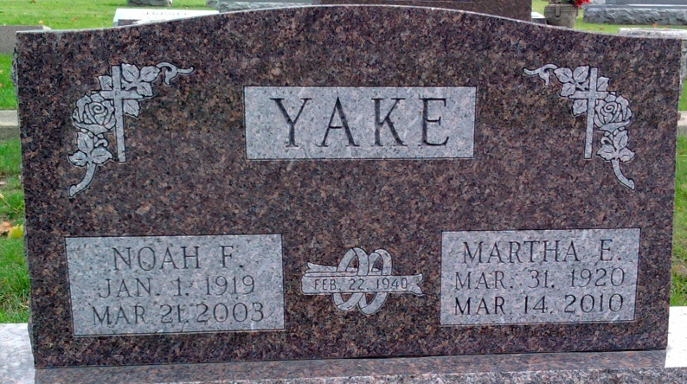
Photo by Thomas Liby

Martha Elizabeth Yake, 89, of Bluffton, a former resident of Craigville, passed away at 7:42 p.m., Sunday, March 14, 2010, at River Terrace Estates.
She was born March 31, 1920, in Adams County, to Cary O. Zirkle and Effie E. Studebaker Zirkle. She married Noah F. Yake Feb. 22, 1940, in Craigville; her husband preceded her in death on March 21, 2003.
Mrs. Yake graduated from Lancaster High School and was a homemaker. She was a member of the Pleasant Dale Church of the Brethren and volunteered as a docent at the Fort Wayne Children's Zoo for 10 years.
Survivors include three sons, Frederick Yake of Craigville, Kenneth E. (Nan) Yake of Bluffton, and Donald L. (Susan) Yake of Bluffton, and seven grandchildren and 11 great-grandchildren. Mrs. Yake was preceded in death by a brother, George E. Zirkle, a sister, Mary M. Zirkle, and two great-grandchildren.
Calling hours are 2 to 8 p.m. Wednesday, March 17, 2010, and from 9:30 to 10:30 a.m. Thursday, March 18, at the Thoma/Rich, Chaney & Lemler Funeral Home in Bluffton. Funeral services will be held at 10:30 a.m. Thursday, March 18, 2010, at the funeral home with Pastor Jay Carter and Pastor Mike Overpeck officiating. Burial will be at the Elm Grove Cemetery in Bluffton.
Preferred memorials are to Pleasant Dale Church of the Brethren.

Bluffton News-Banner, Wells County, Indiana
March 14, 2010

