Lewis E. Yake
March 21, 1886 – April 11, 1972

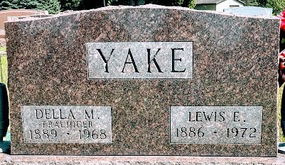
Photo by SMMR

Lewis E. Yake Dies at Hospital
Lewis E. Yake, 86, of Bluffton route 4, a former resident of Adams County, died at 6:15 p.m. Tuesday at the Clinic Hospital in Bluffton, where he had been admitted earlier in the day.
He was a son of Herman and Wilhelmina Martin-Yake, and lived in Kirkland Township until 1942. He was married to Della Frauhiger Oct. 10, 1911, in Craigville, and she preceded him in death June 15, 1968. Mr. Yake was a member of the Criagville United Methodist church.
Surviving are two sons, Evan Yake of Decatur route 2, and Noah Yake of Craigville; three daughters, Mrs. Virgil (Ruth) Henschen of Wakarusa, Mrs. Harry (Hazel) Liechty of Berne, and Mrs. Naomie Siela of Bluffton route 1; one sister, Mrs. Anna Warthman of Craigville; 14 grandchildren and 15 great-grandchildren.
Funeral rites will be held at 1:30 p.m. Friday at the Craigville United Methodist church, with Ref. Paul Fulp officiating. Burial will be in Elm Grove Cemetery, Bluffton. Friends may call at the Thoma funeral home in Bluffton after 7 p.m. today noon Friday.

Decatur Daily Democrat, Adams County, Indiana
Wednesday, April 12, 1972

**
Indiana, Death Certificates, 1899-2011
Name: Lewis E Yake
Gender: Male
Race: White
Age: 86
Marital status: Widowed
Birth Date: 21 Mar 1886
Birth Place: Indiana
Death Date: 11 Apr 1972
Death Place: Bluffton, Wells, Indiana, USA
Father: Herman Yake
Mother: Wilhemena Martin
Informant: none listed
Burial: April 14, 1972; Elm Grove Cemetery; Bluffton, Indiana

