Della M. (Frauhiger) Yake
May 10, 1889 – June 15, 1968

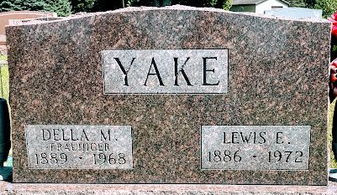
Photo by SMMR

Mrs. Della Yake, 79, wife of Lewis Yake of Bluffton, Route 4 died at Clinic Hospital today. Born May 10, 1889, in Wells County, she was a daughter of Philip and Bertha Meyer Frauhiger. Her marriage to Mr. Yake, who survives, took place on October 10, 1911, in Wells County.
Surviving, in addition to the husband are three daughters, Mrs. Virgil (Ruth) Henschen of Wakarusa, Mrs. Harry (Hazel) Liechty of Berne, Route 1, and Mrs. Naomi Siela of Bluffton, Route 1, and two sons, Evan E. of Decatur, Route 2, and Noah F. of Craigville, Route 1. Also surviving are two sisters, Mrs. Emma Schilickman of Adams County and Mrs. Forest (Nettie) Mankey of Craigville, Route 1; two brothers, Harry Frauhiger of Decatur and Albert Frauhiger of Ohio; 14 grandchildren and seven great-grandchildren.
The Thoma Funeral Home is in charge with services to be Monday at the Craigville United Methodist Church. Burial in Elm Grove Cemetery.

Bluffton News-Banner, Wells County, Indiana
June 15, 1968

**
Indiana, Death Certificates, 1899-2011
Name: Della M Yake
[Della M Frauhiger]
Gender: Female
Race: Wh
Age: 79
Marital status: M
Birth Date: 10 May 1889
Birth Place: Indiana
Death Date: 15 Jun 1968
Death Place: Bluffton, Wells, Indiana, USA
Father: Phillip Frauhiger; deceased
Mother: Bertha Myers; deceased
Spouse: Lewis E Yake
Informant: Lewis Yake; husband; Bluffton, Indiana
Burial: June 17, 1968; Elm Grove Cemetery; Bluffton, Indiana

