James E. Wyer
May 27, 1887 – March 9, 1967

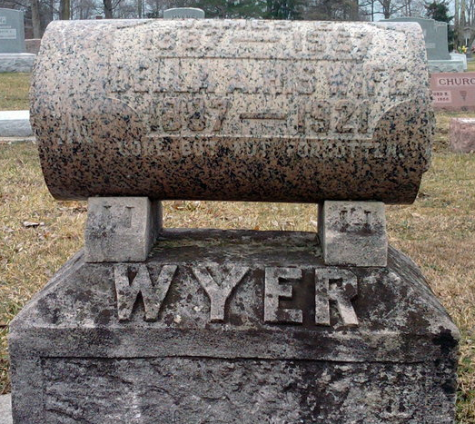
Photo by Thomas Liby

James E Wyer
in the Indiana, U.S., Death Certificates, 1899-2017
Name James E Wyer
Gender Male
Race Caucasian (White)
Marital Status Married
Age 79
Birth Date 27 May 1887
Birth Place Indiana
Death Date 9 Mar 1967
Death Place Hoagland, Allen, Indiana, USA
Death Registration Date 1967
Father Jacob Wyer
Mother Prissilla Martin
Informant Rose Wyer; wife; Hoagland, Indiana
Burial March 12, 1967; Elm Grove Cemetery; Bluffton, Indiana

