Grace Iona (Bell) Harmon-Wyer
November 22, 1894 – January 18, 1961

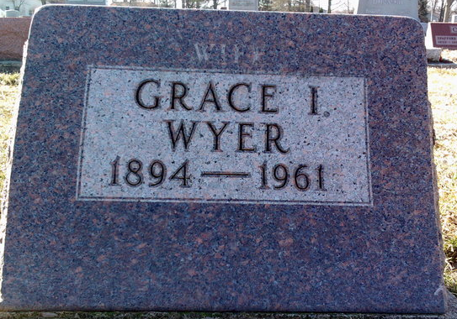
Photo by Thomas Liby

GRACE I. WYER

VAN WERT – Grace I. Wyer, 66, of Willshire, died at 2 a.m. today in Adams County Memorial Hospital, Decatur, Indiana, where she had been a patient one week.
She was born Nov. 22, 1894 in Harrison Township, a daughter of Lafayette and Nessie (Balyeat) Bell. She was married February 28, 1922 to James E. Wyer, who survives.
Also surviving are two sons, Albert, Albuquerque, N.M. and Ivan, Willshire; one step-daughter, Mrs. Ervin (Elizabeth) Rinard, St. Joe, Ind.; a brother, Clarence Bell, Shepherd, Mich.; seven grandchildren and five great-grandchildren.
One sister and one brother are deceased.
She was a member of the Eastern Star, Willshire Pythian Sisters and the Willshire Methodist Church.
Funeral services will be held at 1:30 p.m. Thursday in the Zwick Funeral Home in Decatur, Ind., with Rev. William Powers to officiate. Burial will be in the Elm Grove Cemetery in Bluffton, Ind. Friends may call at the funeral home after 7 p.m. today.

Lima News; Allen County, Ohio
January 18, 1961
**

Michigan, U.S., Marriage Records, 1867-1952
Name Grace Iona Bell
Gender Female
Race White
Age 23
Birth Date abt 1895
Birth Place Indiana
Marriage Date 14 Jun 1918
Marriage Place Hillsdale, Hillsdale, Michigan, USA
Residence Place Muncie, Indiana
Father La Fayette Bell
Mother Nittie Balliet
Spouse Walter McKinley Harman
Record Number 10510
**

Ohio, U.S., County Marriage Records, 1774-1993
Name Grace Harmon
[Grace Bell]
Gender Female
Marriage Age 27
Birth Date abt 1895
Marriage Date 28 Jan 1922
Marriage Place Van Wert, Ohio, USA
Father Lafayette Bell
Mother Nessie Balyrat
Spouse J E Wyer
Film Number 001015952

