Della A. (Sovine) Wyer
June 2, 1887 – February 28, 1921

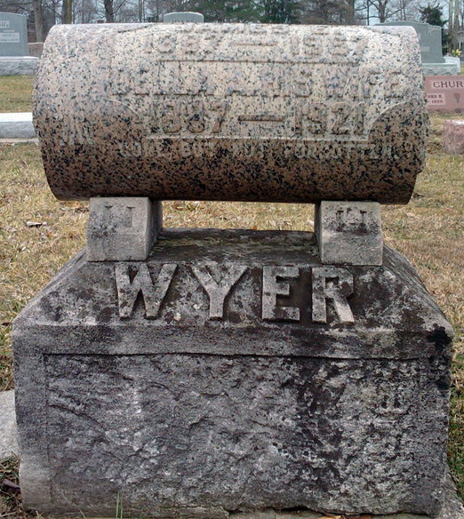
Photo by Thomas Liby

Ohio, County Death Records, 1840-2001
Name Della A. Wyer
Sex Female
Age 33 years 7 months 26 days
Birth Date June 2, 1887
Birthplace Indiana
Burial Date March 2, 1921
Burial Place Blufton, Ind.
Marital Status Married
Race White
Father's Name John Sovine
Father's Birthplace Indiana
Mother's Name Elizabeth Hower
Mother's Birthplace Indiana
Event Type Death
Event Date February 28, 1921
Event Place Willshire, Willshire Township, Van Wert, Ohio, United States
Source Details item 15 cn 58
Informant J. E. Wyer; Willshire, Ohio
Additional Relatives X

