David Lewis Wyer
June 9, 1908 – October 21, 1921

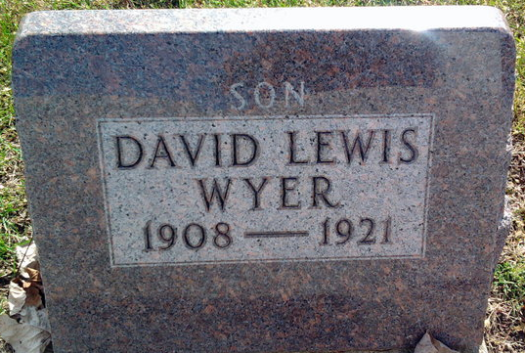
Photo by Thomas Liby

Ohio, County Death Records, 1840-2001
Name David Louis Wyer
Sex Male
Age 13 years 4 months 11 days
Birth Date June 9, 1908
Birthplace Indiana
Burial Date October 23, 1921
Burial Place Blufton, Ind.
Race White
Father's Name James E. Wyer
Father's Birthplace Indiana
Mother's Name Della Sovine
Mother's Birthplace Indiana
Event Type Death
Event Date October 21, 1921
Event Place (Original) Willshire Township, Willshire, Van Wert, Ohio, United States
Source Details item 15 cn 72
Informant James E. Wyer; Willshire, Ohio
Additional Relatives X

