David A. Wyer
August 1, 1871 – September 25, 1921

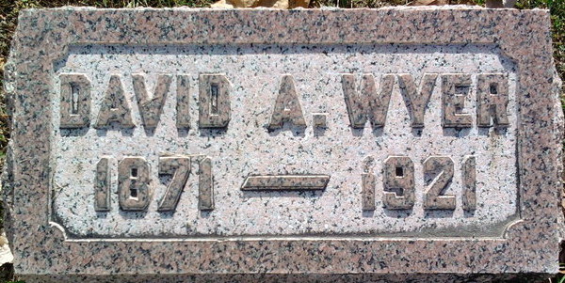
Photo by Thomas Liby

Death • Ohio, County Death Records, 1840-2001
Name David A. Wyer
Sex Male
Age 50 years 1 months 24 days
Birth Date August 1, 1871
Birthplace Indiana
Burial Date September 28, 1921
Burial Place Blufton, Ind.
Marital Status Single
Race White
Father's Name Jacob Wyer
Father's Birthplace Ohio
Mother's Name Priscilla Martin
Mother's Birthplace Ohio
Event Type Death
Event Date September 25, 1921
Event Place (Original) Willshire Township, Willshire, Van Wert, Ohio, United States
Source Details item 15 cn 69
Informant J. E. Wyer; Willshire, Ohio
Additional Relatives X

